# REPORT On WEB

# DEVELOPMENT

# 

E-COMMERCE WEBSITE



**Submitted by: Submitted to:**

TUSHAR SAXENA Mr. Anand Prakash Gupta

(171500361) CSE Dept , GLA University

RIYA NARAIN

(171500264)

CONTENTS

Abstract

1. Introduction

1.1 General Introduction to the topic

1.2 Area of Computer Science

1.3 Hardware and Software Requirements

2. Problem definition

3. Objectives

4. Methodology

5. Implementation details

6. Contribution summary (only for a group project - divide the work and list who is responsible for which part)

7. Progress till date & the Remaining work

8. References

ABSTRACT

Our project is dropin This is a website which helps customers to find and buy all type of products on internet. It is useful in the way that it makes an easier way to buy and makes them available at a lower price **dropin** is an interactive e-commerce solution providing users with an opportunity to order products on the basis of how low they want to pay.

In this website we have basically 2 modules. The first module includes the customer portal and second module includes admin portal.

The customer have to register for any enquiry related to products. The registered customer can view details of products and he/she can buy the product of his/her need. He/she has to pay and will get home delivery accordingly.

The admin portal contains the access of admin page on the website. The admin can change everything in the website. He have the ability to add, delete, and update any information regarding the product, set it's prices and look at the count of orders on a particular product that people have opted for in a particular time slot.

INTRODUCTION

# General Introduction to the topic

We know that the [growth of online business](https://360.shiprocket.in/blog/ecommerce-growth-india-market-research-stats/) worldwide is significantly faster and higher as compared to traditional businesses. The success of eCommerce businesses has been so impacting that even established business houses have started online selling as a complementary effort in their business.

Similarly, we thought of a business idea and wanted to start directly from the web. And through web development and marketing on the platform, we wanted to design a eCommerce website.

This website will aim at the general ecommerce website services, that is connecting suppliers/vendors and customers but at the same time it’ll offer the users something irresistable! We will provide a massdropin service from time to time according to users interest.

Area Of Computer Science

# Web Development

**Web development** is a broad term for the work involved in developing a [web site](https://en.wikipedia.org/wiki/Web_site) for the [Internet](https://en.wikipedia.org/wiki/Internet) ([World Wide Web](https://en.wikipedia.org/wiki/World_Wide_Web)) or an [intranet](https://en.wikipedia.org/wiki/Intranet) (a private network). Web development can range from developing the simplest static single page of [plain text](https://en.wikipedia.org/wiki/Plain_text) to the most complex web-based [internet applications](https://en.wikipedia.org/wiki/Internet_application), [electronic businesses](https://en.wikipedia.org/wiki/Electronic_business), and [social network services](https://en.wikipedia.org/wiki/Social_network_service). A more comprehensive list of tasks to which web development commonly refers, may include [web](https://en.wikipedia.org/wiki/Web_engineering) [engineering](https://en.wikipedia.org/wiki/Web_engineering), [web design](https://en.wikipedia.org/wiki/Web_design), [web content development](https://en.wikipedia.org/wiki/Web_content_development), client liaison, [client-side](https://en.wikipedia.org/wiki/Client-side_scripting)/side scripting, [web server](https://en.wikipedia.org/wiki/Web_server) and [network security](https://en.wikipedia.org/wiki/Network_security) configuration, and [e-commerce](https://en.wikipedia.org/wiki/E-commerce) development. Among web professionals, "web development" usually refers to the main non-design aspects of building web sites: writing [markup](https://en.wikipedia.org/wiki/Markup_language) and [coding](https://en.wikipedia.org/wiki/Computer_programming). Most recently Web development has come to mean the creation of [content management systems](https://en.wikipedia.org/wiki/Content_management_system) or CMS. These CMS can be made from scratch, proprietary or open source. In broad terms the CMS acts as middleware between the database and the user through the browser. A principle benefit of a CMS is that it allows non-technical people to make changes to their web site without having technical knowledge.

For larger organizations and businesses, web development teams can consist of hundreds of people ([web developers](https://en.wikipedia.org/wiki/Web_developer)) and follow standard methods like [Agile methodologies](https://en.wikipedia.org/wiki/Agile_software_development) while developing websites. Smaller organizations may only require a single permanent or contracting developer, or secondary assignment to related job positions such as a [graphic](https://en.wikipedia.org/wiki/Graphic_designer) [designer](https://en.wikipedia.org/wiki/Graphic_designer) or [information systems](https://en.wikipedia.org/wiki/Information_systems) technician. Web development may be a collaborative effort between departments rather than the domain of a designated department. There are three kind of web developer specialization: front-end developer, back-end developer, and full-stack developer.

# 

# WEB-SITE

A **website** is a collection of related [web pages](https://en.wikipedia.org/wiki/Web_page), including [multimedia](https://en.wikipedia.org/wiki/Multimedia) content, typically identified with a common [domain name,](https://en.wikipedia.org/wiki/Domain_name) and published on at least one [web server](https://en.wikipedia.org/wiki/Web_server). A website may be accessible via a public [Internet Protocol](https://en.wikipedia.org/wiki/Internet_Protocol) (IP) network, such as the [Internet](https://en.wikipedia.org/wiki/Internet), or a private [local area network](https://en.wikipedia.org/wiki/Local_area_network) (LAN), by referencing a [uniform resource locator](https://en.wikipedia.org/wiki/URL) (URL) that identifies the

site.

Websites have many functions and can be used in various fashions; a website can be a [personal website](https://en.wikipedia.org/wiki/Personal_website), a commercial website for a company, a [government website](https://en.wikipedia.org/wiki/E-Government) or a [non-profit](https://en.wikipedia.org/wiki/Nonprofit_organization) [organization](https://en.wikipedia.org/wiki/Nonprofit_organization) website. Websites are typically dedicated to a particular topic or purpose, ranging from entertainment and [social networking](https://en.wikipedia.org/wiki/Social_networking) to providing news and education. All publicly accessible websites collectively constitute the [World Wide Web](https://en.wikipedia.org/wiki/World_Wide_Web), while private websites, such as a company's website for its employees, andare typically a part of an [intranet.](https://en.wikipedia.org/wiki/Intranet)

Web pages, which are the [building blocks](https://en.wikipedia.org/wiki/Building_block) of websites, are [documents](https://en.wikipedia.org/wiki/Document), typically composed in [plain text](https://en.wikipedia.org/wiki/Plain_text) interspersed with formatting instructions of Hypertext Markup Language ([HTML,](https://en.wikipedia.org/wiki/HTML) [XHTML](https://en.wikipedia.org/wiki/XHTML)). They may incorporate elements from other websites with suitable [markup anchors](https://en.wikipedia.org/wiki/HTML_anchor). Web pages are accessed and transported with the [Hypertext Transfer](https://en.wikipedia.org/wiki/Hypertext_Transfer_Protocol) [Protocol](https://en.wikipedia.org/wiki/Hypertext_Transfer_Protocol) (HTTP), which may optionally employ encryption ([HTTP Secure](https://en.wikipedia.org/wiki/HTTP_Secure), HTTPS) to provide security and privacy for the user. The user's application, often a [web browser](https://en.wikipedia.org/wiki/Web_browser), renders the page content according to its HTML markup instructions onto a [display terminal](https://en.wikipedia.org/wiki/Computer_monitor).

[Hyperlinking](https://en.wikipedia.org/wiki/Hyperlink) between web pages conveys to the reader the [site structure](https://en.wikipedia.org/wiki/Site_map) and guides the navigation of the site, which often starts with a [home page](https://en.wikipedia.org/wiki/Home_page) containing a directory of the site [web content](https://en.wikipedia.org/wiki/Web_content). Some websites require user registration or [subscription](https://en.wikipedia.org/wiki/Subscription) to access content. Examples of [subscription websites](https://en.wikipedia.org/wiki/Paywall) include many business sites, news websites, [academic](https://en.wikipedia.org/wiki/Academic_journal) [journal](https://en.wikipedia.org/wiki/Academic_journal) websites, gaming websites, file-sharing websites, [message boards](https://en.wikipedia.org/wiki/Internet_forum), web-based [email](https://en.wikipedia.org/wiki/Email), [social networking](https://en.wikipedia.org/wiki/Social_networking) websites, websites providing real-time [stock market](https://en.wikipedia.org/wiki/Stock_market) data, as well as sites providing various other services. As of 2016 [end users](https://en.wikipedia.org/wiki/End_user) can access websites on a range of devices, including [desktop](https://en.wikipedia.org/wiki/Desktop_computer) and [laptop computers](https://en.wikipedia.org/wiki/Laptop), [tablet computers](https://en.wikipedia.org/wiki/Tablet_computer), [smartphones](https://en.wikipedia.org/wiki/Smartphone) and [smart](https://en.wikipedia.org/wiki/Smart_TV) [TVs.](https://en.wikipedia.org/wiki/Smart_TV)

A web site consists of web pages which are interconnected to each other and contain various data and functionalities.

# 

# 

# WEB-PAGE

A **web page**, or **webpage**, is a document that is suitable for the [World Wide Web](https://en.wikipedia.org/wiki/World_Wide_Web) and [web browsers](https://en.wikipedia.org/wiki/Web_browser). A web browser displays a web page on a [monitor](https://en.wikipedia.org/wiki/Computer_display) or [mobile device](https://en.wikipedia.org/wiki/Mobile_device). The web page is what displays, but the term also refers to a [computer file](https://en.wikipedia.org/wiki/Computer_file), usually written in [HTML](https://en.wikipedia.org/wiki/HTML) or comparable [markup language](https://en.wikipedia.org/wiki/Markup_language). Web browsers coordinate the various [web resource](https://en.wikipedia.org/wiki/Web_resource) elements for the written web page, such as [style sheets](https://en.wikipedia.org/wiki/Cascading_Style_Sheets), [scripts](https://en.wikipedia.org/wiki/Client-side_scripting), and [images](https://en.wikipedia.org/wiki/Image), to present the web page.

Typical web pages provide [hypertext](https://en.wikipedia.org/wiki/Hypertext) that includes a [navigation bar](https://en.wikipedia.org/wiki/Navigation_bar) or a [sidebar](https://en.wikipedia.org/wiki/Sidebar_%28computing%29) [menu](https://en.wikipedia.org/wiki/Menu_%28computing%29) to other web pages via [hyperlinks](https://en.wikipedia.org/wiki/Hyperlink), often referred to as links.

On a network, a web browser can retrieve a web page from a remote [web server](https://en.wikipedia.org/wiki/Web_server). On a higher level, the web server may restrict access to only a private network such as a corporate [intranet](https://en.wikipedia.org/wiki/Intranet) or it provides access to the World Wide Web. On a lower level, the web browser uses the [Hypertext Transfer Protocol](https://en.wikipedia.org/wiki/Hypertext_Transfer_Protocol) (HTTP) to make such requests.

A [static web page](https://en.wikipedia.org/wiki/Static_web_page) is delivered exactly as stored, as [web content](https://en.wikipedia.org/wiki/Web_content) in the web server's [file](https://en.wikipedia.org/wiki/File_system) [system,](https://en.wikipedia.org/wiki/File_system) while a [dynamic web page](https://en.wikipedia.org/wiki/Dynamic_web_page) is generated by a [web application](https://en.wikipedia.org/wiki/Web_application) that is driven by [server-](https://en.wikipedia.org/wiki/Server-side_scripting) [side software](https://en.wikipedia.org/wiki/Server-side_scripting) or client-side scripting. Dynamic website pages help the browser (the [client](https://en.wikipedia.org/wiki/Client_%28computing%29)) to enhance the web page through user input to the server.

# THE STEPS TO CREATE A WEB SITE

Creating a web site requires multiple steps which includes the following:

* Creating a UI(User interface)
* Scripting(Both at server end and client end)
* Creating a backend or the database

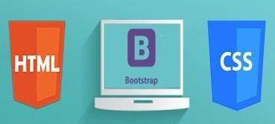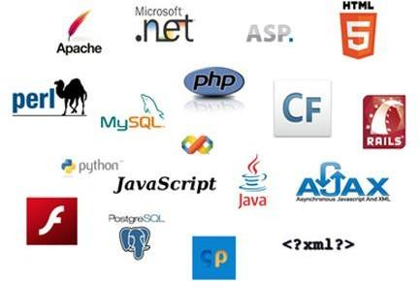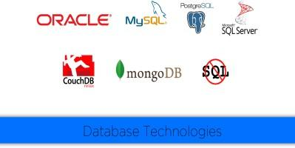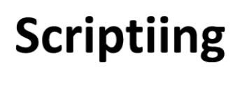

[](https://pixabay.com/vectors/positive-thinking-creative-brain-3616556/)

## TECHNOLOGIES USED

## HTML

## CSS

## JAVASCRIPT

## PHP

## SQL

## 

## 

## 

# 

# PROBLEM DEFINITION

We see websites making money by just showing how they can sell products a lower costs.

The base reason behind this is that these companies give huge orders to the manufacturers that in turn gift them the low cost price that these sellers sell on their own terms and prices at what they want.

This website allows the customers to be the soul decider of their prices, i.e., the price of the product will depend on the no. of people buying the same product. The larger the orders the lesser the price.

# OBJECTIVE

The war for lower price for customers ends. Customers decide the price for the product. The more orders results manufacturer to lower their selling prices and hence lower cost to the customers. The main objective of the ideology of the website is to provide options to customers to allow them to make bold choices and get product on a much lower prices. To develop an easy to use web based interface where customers can search for products, view a complete description of the product and order the product i.e customer can buy from home.

# COMPONENTS OF WEBSITE

* E-Commerce website/portal
* Sign-up/login with customer database
* Products, interests according to user
* Online transaction.
* Sales/Orders/Shipments page
* Coupons/discount management
* Page details/blogs/sponsors

# TARGET AUDIENCES:

Target audience will be based upon interests, products marketed, advertisements, emails which will direct the audience to our website. Audiences will also be targeted through sales and coupons. We will be also including a payment gateway on our website for conversions.

# FUTURE SCOPE:

The website will be collecting data according to user interest through which we will improve our feature of mass dropin. We will also be linking it to Google Analytics which will provide us with a complete analysis of the website along with the implemented funnels, conversion rate, bounce rate etc which will help us improve the website.

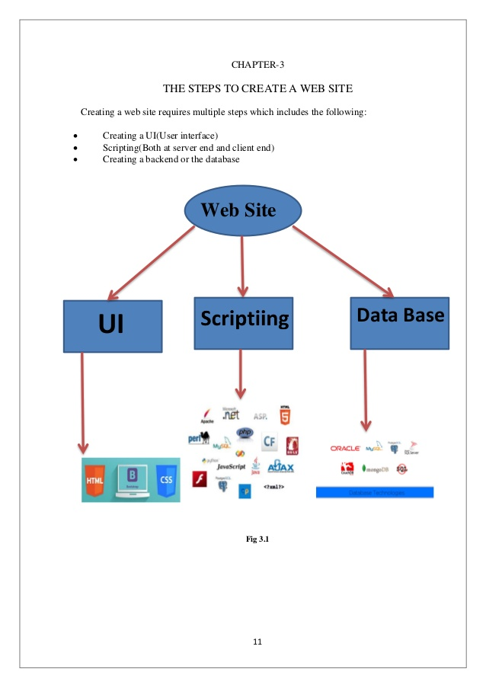

UI Development:

# 

# HTML 5

**Hypertext Markup Language** (**HTML**) is the standard [markup language](https://en.wikipedia.org/wiki/Markup_language) for creating [web pages](https://en.wikipedia.org/wiki/Web_page) and [web applications](https://en.wikipedia.org/wiki/Web_application). With [Cascading Style Sheets](https://en.wikipedia.org/wiki/Cascading_Style_Sheets) (CSS) and [JavaScript](https://en.wikipedia.org/wiki/JavaScript) it forms a triad of cornerstone technologies for the [World Wide Web](https://en.wikipedia.org/wiki/World_Wide_Web). [Web browsers](https://en.wikipedia.org/wiki/Web_browser) receive HTML documents from a [webserver](https://en.wikipedia.org/wiki/Webserver) or from local storage and render them into multimedia web pages. HTML describes the structure of a web page [semantically](https://en.wikipedia.org/wiki/Semantic) and originally included cues for the appearance of the document.

[HTML elements](https://en.wikipedia.org/wiki/HTML_element) are the building blocks of HTML pages. With HTML constructs, [images](https://en.wikipedia.org/wiki/Img_%28HTML_element%29) and other objects, such as [interactive forms,](https://en.wikipedia.org/wiki/Fieldset) may be embedded into the rendered page. It provides a means to create [structured documents](https://en.wikipedia.org/wiki/Structured_document) by denoting structural [semantics](https://en.wikipedia.org/wiki/Semantics) for text such as headings, paragraphs, lists, [links](https://en.wikipedia.org/wiki/Hyperlink), quotes and other items. HTML elements are delineated by tags, written using [angle brackets](https://en.wikipedia.org/wiki/Bracket#Angle_brackets). Tags such as <img /> and <input /> introduce content into the page directly. Others such as <p>...</p> surround and provide information about document text and may include other tags as sub-elements. Browsers do not display the HTML tags, but use them to interpret the content of the page.

HTML can embed programs written in a [scripting language](https://en.wikipedia.org/wiki/Scripting_language) such as [JavaScript](https://en.wikipedia.org/wiki/JavaScript) which affect the behavior and content of web pages. Inclusion of CSS defines the look and layout of content. The [World Wide Web Consortium](https://en.wikipedia.org/wiki/World_Wide_Web_Consortium) (W3C), maintainer of both the HTML and the CSS standards, has encouraged the use of CSS over explicit presentational HTML since 1997.

HTML markup consists of several key components, including those called tags (and their attributes), character-based data types, character references and entity references. HTML tags most commonly come in pairs like <h1> and </h1>, although some represent empty elements and so are unpaired, for example <img>. The first tag in such a pair is the start tag, and the second is the end tag (they are also called opening tags and closing tags)

The following is an example of the classic [Hello world program,](https://en.wikipedia.org/wiki/Hello_world_program) a common test employed for comparing [programming languages](https://en.wikipedia.org/wiki/Programming_language), [scripting languages](https://en.wikipedia.org/wiki/Scripting_language) and [markup languages](https://en.wikipedia.org/wiki/Markup_language). This example is made using 9 [lines of code](https://en.wikipedia.org/wiki/Lines_of_code):

General Syntax of HTML

<!DOCTYPE html>

<html>

<head>

<title>This is a title</title>

</head>

<body>

<p>Hello world!</p>

</body>

</html>

(The text between <html> and </html> describes the web page, and the text between <body> and </body> is the visible page content. The markup text "<title>This is a title</title>" defines the browser page title.)

The Document Type Declaration <!DOCTYPE html> is for HTML5. If a declaration is not included, various browsers will revert to "[quirks mode](https://en.wikipedia.org/wiki/Quirks_mode)" for rendering.

# Css:

**Cascading Style Sheets** (**CSS**) is a [style sheet language](https://en.wikipedia.org/wiki/Style_sheet_language) used for describing the [presentation](https://en.wikipedia.org/wiki/Presentation_semantics) of a document written in a [markup language](https://en.wikipedia.org/wiki/Markup_language). Although most often used to set the visual style of [web pages](https://en.wikipedia.org/wiki/Web_page) and user interfaces written in [HTML](https://en.wikipedia.org/wiki/HTML) and [XHTML](https://en.wikipedia.org/wiki/XHTML), the language can be applied to any [XML](https://en.wikipedia.org/wiki/XML) document, including [plain XML](https://en.wikipedia.org/wiki/Plain_Old_XML), [SVG](https://en.wikipedia.org/wiki/Scalable_Vector_Graphics) and [XUL](https://en.wikipedia.org/wiki/XUL), and is applicable to rendering in [speech](https://en.wikipedia.org/wiki/Speech_synthesis), or on other media. Along with HTML and [JavaScript](https://en.wikipedia.org/wiki/JavaScript), CSS is a cornerstone technology used by most websites to create visually engaging webpages, user interfaces for [web applications](https://en.wikipedia.org/wiki/Web_applications), and user interfaces for many mobile applications.

CSS is designed primarily to enable the separation of presentation and content, including aspects such as the [layout](https://en.wikipedia.org/wiki/Page_layout), [colors](https://en.wikipedia.org/wiki/Color), and [fonts](https://en.wikipedia.org/wiki/Typeface). This separation can improve content [accessibility](https://en.wikipedia.org/wiki/Accessibility), provide more flexibility and control in the specification of presentation characteristics, enable multiple HTML pages to share formatting by specifying the relevant CSS in a separate .css file, and reduce complexity and repetition in the structural content.

Separation of formatting and content makes it possible to present the same markup page in different styles for different rendering methods, such as on-screen, in print, by voice (via speech-based browser or [screen reader](https://en.wikipedia.org/wiki/Screen_reader)), and on [Braille-based](https://en.wikipedia.org/wiki/Braille_display) tactile devices. It can also display the web page differently depending on the screen size or viewing device. Readers can also specify a different style sheet, such as a CSS file stored on their own computer, to override the one the author specified.

Changes to the [graphic design](https://en.wikipedia.org/wiki/Graphic_design) of a document (or hundreds of documents) can be applied quickly and easily, by editing a few lines in the CSS file they use, rather than by changing markup in the documents.

The CSS specification describes a priority scheme to determine which style rules apply if more than one rule matches against a particular element. In this so-called cascade, priorities (or weights) are calculated and assigned to rules, so that the results are predictable.

The CSS specifications are maintained by the [World Wide Web Consortium](https://en.wikipedia.org/wiki/World_Wide_Web_Consortium) (W3C). Internet media type ([MIME type](https://en.wikipedia.org/wiki/MIME_media_type)) text/css is registered for use with CSS by [RFC 2318](https://tools.ietf.org/html/rfc2318) (March 1998). The W3C operates a free [CSS validation service](https://en.wikipedia.org/wiki/W3C_Markup_Validation_Service#CSS_validation) for CSS documents

Types of CSS:

* Inline CSS:

In this CSS is applied in between the tags

* Internal CSS:

Eg: <tag style=”styling”>Hello World</tag>

In this Thecss code is defined inside the style tag in the head section of the HTML page.

General Syntax:

<html>

<head>

<style>

<! -- CSS STYLING -- >

</style>

</head>

</html>

External CSS:

In this the CSS code is written on another page and is linked to the HTML page. It is advantageous to use this type of styling as we can use the same file to style various HTML pages.

External CSS uses the extension .css and is applied using the following syntax

<html>

<head>

<link relation=”stylesheet” type=”css” href=”url to the page”>

</head>

</html>

All the CSS style types are important but can be used in different situations.

* Inline CSS is used when only small changes are to be done to the HTML tag and the changes are to be reflected only to that specific tag
* Internal CSS is used when the individual HTML pages have to be designed differently. This also slows the page load system if the internal styling is long.
* External CSS files are maintained to design multiple pages and use common styles over various pages. It is useful as it helps in managing the resources in an easy manner.

*Both HTML and CSS are used to create a UI but CSS behaves like a makeup on the face of an actress which makes her look even more beautiful than she is in reality.*

And here is the difference:

Before using CSS in HTML page:

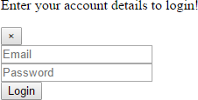

After using CSS in HTML Page: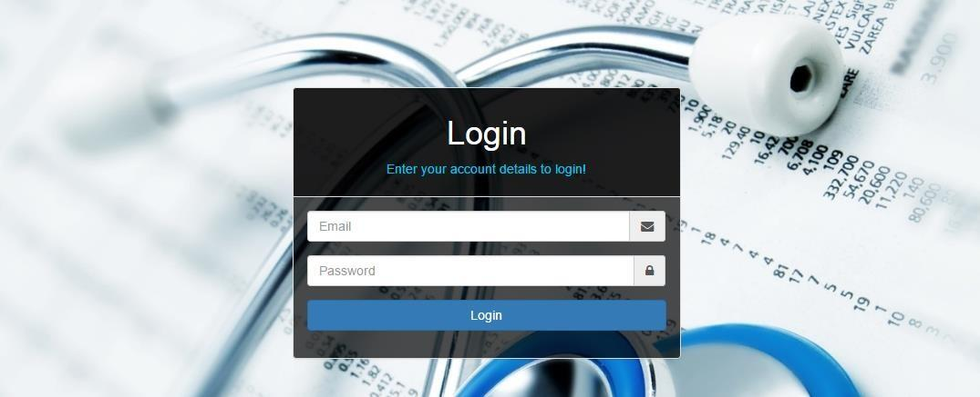

# 

# BOOTSTRAP

**Bootstrap** is a [free and open-source](https://en.wikipedia.org/wiki/Free_and_open-source_software) front-end [web framework](https://en.wikipedia.org/wiki/Web_framework) for designing [websites](https://en.wikipedia.org/wiki/Website) and [web applications](https://en.wikipedia.org/wiki/Web_application). It contains [HTML](https://en.wikipedia.org/wiki/HTML)- and [CSS](https://en.wikipedia.org/wiki/CSS)-based design templates for [typography](https://en.wikipedia.org/wiki/Typography), forms, buttons, navigation and other interface components, as well as optional [JavaScript](https://en.wikipedia.org/wiki/JavaScript) extensions. Unlike many web frameworks, it concerns itself with [front-end development](https://en.wikipedia.org/wiki/Front-end_web_development) only.

Bootstrap is the second most-starred project on [GitHub](https://en.wikipedia.org/wiki/GitHub), with more than 107,000 stars and 48,000 forks.

Bootstrap, originally named Twitter Blueprint, was developed by Mark Otto and Jacob Thornton at [Twitter](https://en.wikipedia.org/wiki/Twitter) as a framework to encourage consistency across internal tools. Before Bootstrap, various libraries were used for interface development, which led to inconsistencies and a high maintenance burden. According to [twitter](https://en.wikipedia.org/wiki/Twitter) developer Mark Otto:

“A super small group of developers and I got together to design and build a new internal tool and saw an opportunity to do something more. Through that process, we saw ourselves build

something much more substantial than another internal tool. Months later, we ended up with an early version of Bootstrap as a way to document and share common design

patterns and assets within the company.”

After a few months of development by a small group, many developers at Twitter began to contribute to the project as a part of Hack Week, a [hackathon](https://en.wikipedia.org/wiki/Hackathon)-style week for the Twitter development team. It was renamed from Twitter Blueprint to Bootstrap, and released as a

open source project on August 19, 2011. It has continued to be maintained by Mark Otto, Jacob Thornton, and a small group of core developers, as well as a large community of contributors.

On January 31, 2012, Bootstrap 2 was released, which added a twelve-column [responsive](https://en.wikipedia.org/wiki/Responsive_web_design) grid layout system, inbuilt support for Glyphicons, several new components, as well as changes to many of the existing components.

On August 19, 2013, Bootstrap 3 was released, which redesigned components to use [flat design](https://en.wikipedia.org/wiki/Flat_design), and a [mobile first](https://en.wikipedia.org/wiki/Responsive_web_design#Mobile_first.2C_unobtrusive_JavaScript.2C_and_progressive_enhancement) approach.

On October 29, 2014, Mark Otto announced that Bootstrap 4 was in development. The first alpha version of Bootstrap 4 was released on August 19, 2015.

Bootstrap 3 supports the latest versions of the [Google Chrome](https://en.wikipedia.org/wiki/Google_Chrome), [Firefox](https://en.wikipedia.org/wiki/Firefox), [Internet](https://en.wikipedia.org/wiki/Internet_Explorer) [Explorer](https://en.wikipedia.org/wiki/Internet_Explorer), [Opera](https://en.wikipedia.org/wiki/Opera_%28web_browser%29), and [Safari](https://en.wikipedia.org/wiki/Safari_%28web_browser%29) (except on Windows). It additionally supports back to [IE8](https://en.wikipedia.org/wiki/Internet_Explorer_8) and the latest [Firefox](https://en.wikipedia.org/wiki/Firefox) Extended Support Release (ESR).

Since 2.0, Bootstrap supports [responsive web design](https://en.wikipedia.org/wiki/Responsive_Web_Design). This means the layout of web pages adjusts dynamically, taking into account the characteristics of the device used (desktop, tablet, mobile phone).

Starting with version 3.0, Bootstrap adopted a [mobile-first design](https://en.wikipedia.org/wiki/Mobile-first_design) philosophy, emphasizing responsive design by default.

The version 4.0 alpha release added [Sass](https://en.wikipedia.org/wiki/Sass_%28stylesheet_language%29) and [flexbox](https://en.wikipedia.org/wiki/CSS_Flex_Box_Layout) support.

Installing and linking bootstrap to the HTML page:

Install bootstrap from <https://getbootstrap.com/>

Copy the bootstrap.min.css file to your CSS folder and link it to the HTML page in the similar manner to how any other CSS file is linked.

Link the bootstrap.min.js file which is present in the JS folder of the bootstrap. It can be linked using script tag.

Eg: <script src=”url to bootstrap.min.js”></script>

Now use bootstrap classes to reduce the work of designing which was earlier done through CSS.

# SCRIPTING

There are two scripting methodologies.

* 1. Server side scripting: This scripting is done at the server end
  2. Client side scripting: This scripting is done at the client end or the browser.

# 

# SERVER SIDE SCRIPTING

**Server-side scripting** is a technique used in [web development](https://en.wikipedia.org/wiki/Web_development) which involves employing [scripts](https://en.wikipedia.org/wiki/Scripting_language) on a web server which produce a response customized for each user’s (client’s) request to the website. The alternative is for the web server itself to deliver a [static](https://en.wikipedia.org/wiki/Static_web_page) [web page](https://en.wikipedia.org/wiki/Static_web_page). Scripts can be written in any of a number of server-side scripting languages that are available (see below). Server-side scripting is distinguished from [client-side scripting](https://en.wikipedia.org/wiki/Client-side_scripting) where embedded scripts, such as [JavaScript](https://en.wikipedia.org/wiki/JavaScript), are run client-side in a [web browser](https://en.wikipedia.org/wiki/Web_browser), but both techniques are often used together.

Server-side scripting is often used to provide a customized interface for the user. These scripts may assemble client characteristics for use in customizing the response based on those characteristics, the user’s requirements, access rights, etc. Server-side scripting also enables the website owner to hide the source code that generates the interface, whereas with client-side scripting, the user has access to all the code received by the client. A down-side to the use of server-side scripting is that the client needs to make further requests over the network to the server in order to show new information to the user via the web browser. These requests can slow down the experience for the user, place more load on the server, and prevent use of the application when the user is disconnected from the server.

When the server serves data in a commonly used manner, for example according to the [HTTP](https://en.wikipedia.org/wiki/Hypertext_Transfer_Protocol) or [FTP](https://en.wikipedia.org/wiki/File_Transfer_Protocol) [protocols](https://en.wikipedia.org/wiki/Protocol_%28computing%29), users may have their choice of a number of client programs (most modern web browsers can request and receive data using both of those protocols). In the case of more specialized applications, programmers may write their own server, client, and communications protocol that can only be used with one another.

Programs that run on a user’s local computer without ever sending or receiving data over a network are not considered clients, and so the operations of such programs would not be considered client-side operations.

# Server Side scripting Languages

There are several languages that can be used for server-side programming:

* PHP
* ASP.NET (C# OR Visual Basic)
* C++
* Java and JSP
* Python
* Ruby on Rails and so on.

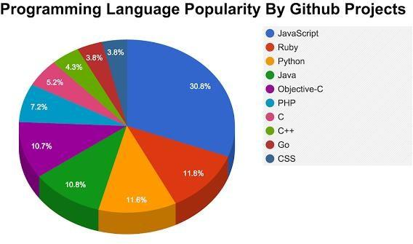

# CLIENT SIDE SCRIPTING

Client-side scripting is changing interface behaviors within a specific web page in response to mouse or keyboard actions, or at specified timing events. In this case, the dynamic behavior occurs within the [presentation](https://en.wikipedia.org/wiki/Look_and_feel). The client-side content is generated on the user's local computer system.

Such web pages use presentation technology called [rich interfaced pages](https://en.wikipedia.org/wiki/Rich_Internet_application#Methods_and_techniques). Client-side scripting languages like [JavaScript](https://en.wikipedia.org/wiki/JavaScript) or [ActionScript](https://en.wikipedia.org/wiki/ActionScript), used for [Dynamic HTML](https://en.wikipedia.org/wiki/Dynamic_HTML) (DHTML) and [Flash](https://en.wikipedia.org/wiki/Adobe_Flash) technologies respectively, are frequently used to orchestrate media types (sound, animations, changing text, etc.) of the presentation. Client-side scripting also allows the use of [remote scripting](https://en.wikipedia.org/wiki/Remote_scripting), a technique by which the DHTML page requests additional information from a server, using a [hidden frame](https://en.wikipedia.org/wiki/HTML_element#Frames), [XML Http Requests](https://en.wikipedia.org/wiki/XMLHttpRequest), or a [Web service](https://en.wikipedia.org/wiki/Web_service).

The first widespread use of JavaScript was in 1997, when the language was standardized as [ECMAScript](https://en.wikipedia.org/wiki/ECMAScript) and implemented in [Netscape 3](https://en.wikipedia.org/wiki/Netscape).

Example:

The client-side content is generated on the client's computer. The web browser retrieves a page from the server, then processes the code embedded in the page (typically written in [JavaScript](https://en.wikipedia.org/wiki/JavaScript)) and displays the retrieved page's content to the user.

The most popularly used client side scripting languages is **Java Script**. Flow of request from browser to server:

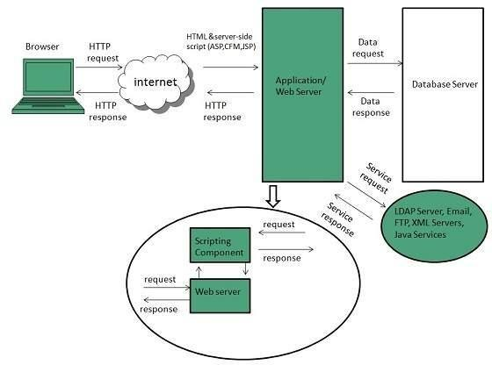

**Fig 3.2.2**

# DATABASE

A **database** is an organized collection of [data.](https://en.wikipedia.org/wiki/Data_%28computing%29) It is the collection of [schemas,](https://en.wikipedia.org/wiki/Database_schema) [tables](https://en.wikipedia.org/wiki/Table_%28database%29), [queries](https://en.wikipedia.org/wiki/Query_language), reports, [views](https://en.wikipedia.org/wiki/View_%28SQL%29), and other objects. The data are typically organized to model aspects of reality in a way that supports [processes](https://en.wikipedia.org/wiki/Process_%28computing%29) requiring information, such as modelling the availability of rooms in hotels in a way that supports finding a hotel with vacancies.

A **database management system** (**DBMS**) is a [computer software](https://en.wikipedia.org/wiki/Computer_software) application that interacts with the user, other applications, and the database itself to capture and analyze data. A general-purpose DBMS is designed to allow the definition, creation, querying, update, and administration of databases. Well-known DBMSs include [MySQL,](https://en.wikipedia.org/wiki/MySQL) [PostgreSQL,](https://en.wikipedia.org/wiki/PostgreSQL) [MongoDB](https://en.wikipedia.org/wiki/MongoDB), [MariaDB](https://en.wikipedia.org/wiki/MariaDB), [Microsoft SQL Server](https://en.wikipedia.org/wiki/Microsoft_SQL_Server), [Oracle](https://en.wikipedia.org/wiki/Oracle_Database), [Sybase](https://en.wikipedia.org/wiki/Sybase), [SAP HANA,](https://en.wikipedia.org/wiki/SAP_HANA) [MemSQL](https://en.wikipedia.org/wiki/MemSQL) and [IBM DB2.](https://en.wikipedia.org/wiki/IBM_DB2)database is not generally [portable](https://en.wikipedia.org/wiki/Software_portability) across different DBMSs, but different DBMS can interoperate by using [standards](https://en.wikipedia.org/wiki/Technical_standard) such as [SQL](https://en.wikipedia.org/wiki/SQL) and [ODBC](https://en.wikipedia.org/wiki/ODBC) or [JDBC](https://en.wikipedia.org/wiki/JDBC) to allow a single application to work with more than one DBMS. Database management systems are often classified according to the [database model](https://en.wikipedia.org/wiki/Database_model) that they support; the most popular database systems since the 1980s have all supported the [relational model](https://en.wikipedia.org/wiki/Relational_model) as represented by the [SQL](https://en.wikipedia.org/wiki/SQL) language. Sometimes a DBMS is loosely referred to as a "database".

# SQL

Originally based upon [relational algebra](https://en.wikipedia.org/wiki/Relational_algebra) and [tuple relational calculus](https://en.wikipedia.org/wiki/Tuple_relational_calculus), SQL consists of a [data definition language](https://en.wikipedia.org/wiki/Data_definition_language), [data manipulation language](https://en.wikipedia.org/wiki/Data_manipulation_language), and [data control language](https://en.wikipedia.org/wiki/Data_control_language). The scope of SQL includes data insert, query, update and delete, [schema](https://en.wikipedia.org/wiki/Database_schema) creation and modification, and data access control. Although SQL is often described as, and to a great extent is, a [declarative](https://en.wikipedia.org/wiki/Declarative_programming) [language](https://en.wikipedia.org/wiki/Declarative_programming) ([4GL](https://en.wikipedia.org/wiki/4GL)), it also includes [procedural](https://en.wikipedia.org/wiki/Procedural_programming) elements.

SQL was one of the first commercial languages for [Edgar F. Codd](https://en.wikipedia.org/wiki/Edgar_F._Codd)'s[relational model](https://en.wikipedia.org/wiki/Relational_model), as described in his influential 1970 paper, "A Relational Model of Data for Large Shared Data Banks." Despite not entirely adhering to [the relational model as described by Codd,](https://en.wikipedia.org/wiki/Codd%27s_12_rules) it became the most widely used database language.

SQL became a [standard](https://en.wikipedia.org/wiki/Technical_standard) of the [American National Standards Institute](https://en.wikipedia.org/wiki/American_National_Standards_Institute) (ANSI) in 1986, and of the [International Organization for Standardization](https://en.wikipedia.org/wiki/International_Organization_for_Standardization) (ISO) in 1987. Since then, the standard has been revised to include a larger set of features. Despite the existence of such standards, most SQL code is not completely portable among different database systems without adjustments.

# QUERIES

The most common operation in SQL, the query, makes use of the declarative [SELECT](https://en.wikipedia.org/wiki/Select_%28SQL%29) statement. SELECT retrieves data from one or more [tables](https://en.wikipedia.org/wiki/Table_%28database%29), or expressions. Standard SELECT statements have no persistent effects on the database. Some non-standard implementations of SELECT can have persistent effects, such as the SELECT INTO syntax provided in some databases.

Queries allow the user to describe desired data, leaving the [database management](https://en.wikipedia.org/wiki/Database_management_system) [system (DBMS)](https://en.wikipedia.org/wiki/Database_management_system) to carry out [planning](https://en.wikipedia.org/wiki/Query_plan), [optimizing](https://en.wikipedia.org/wiki/Query_optimizer), and performing the physical operations necessary to produce that result as it chooses

A query includes a list of columns to include in the final result, normally immediately following the SELECT keyword. An asterisk ("*") can be used to specify that the query should return all columns of the queried tables. SELECT is the most complex statement in SQL, with optional keywords and clauses that include:

* The [FROM](https://en.wikipedia.org/wiki/From_%28SQL%29) clause, which indicates the table(s) to retrieve data from. The FROM clause can include optional [JOIN](https://en.wikipedia.org/wiki/Join_%28SQL%29)subclauses to specify the rules for joining tables.
* The [WHERE](https://en.wikipedia.org/wiki/Where_%28SQL%29) clause includes a comparison predicate, which restricts the rows returned by the query. The WHERE clause eliminates all rows from the result set where the comparison predicate does not evaluate to True.
* The GROUP BY clause projects rows having common values into a smaller set of rows. GROUP BY is often used in conjunction with SQL aggregation functions or to eliminate duplicate rows from a result set. The WHERE clause is applied before the GROUP BY clause.
* The [HAVING](https://en.wikipedia.org/wiki/Having_%28SQL%29) clause includes a predicate used to filter rows resulting from the GROUP BY clause. Because it acts on the results of the GROUP BY clause, aggregation functions can be used in the HAVING clause predicate.
* The [ORDER BY](https://en.wikipedia.org/wiki/Order_by_%28SQL%29) clause identifies which column[s] to use to sort the resulting data, and in which direction to sort them (ascending or descending). Without an ORDER BY clause, the order of rows returned by an SQL query is undefined.
* The DISTINCT keyword eliminates duplicate data.

# SCRIPTING LANGUAGES

# PHP

# 

|  |  |
| --- | --- |
| [**Paradigm**](https://en.wikipedia.org/wiki/Programming_paradigm) | [Imperative](https://en.wikipedia.org/wiki/Imperative_programming), [functional](https://en.wikipedia.org/wiki/Functional_programming), [object-oriented](https://en.wikipedia.org/wiki/Object-oriented_programming), [procedural](https://en.wikipedia.org/wiki/Procedural_programming), [reflective](https://en.wikipedia.org/wiki/Reflective_programming) |
| [**Designed by**](https://en.wikipedia.org/wiki/Software_design) | [RasmusLerdorf](https://en.wikipedia.org/wiki/Rasmus_Lerdorf) |
| [**Developer**](https://en.wikipedia.org/wiki/Software_developer) | The PHP Development Team[, Zend Technologies](https://en.wikipedia.org/wiki/Zend_Technologies) |
| **First appeared** | June 8, 1995; 21 years ago[[1]](https://en.wikipedia.org/wiki/PHP#cite_note-mysqlconference-1) |
| [**Stable release**](https://en.wikipedia.org/wiki/Software_release_life_cycle) | 7.1.5 / May 11, 2017; 16 days ago |
| [**Typing discipline**](https://en.wikipedia.org/wiki/Type_system) | [Dynamic](https://en.wikipedia.org/wiki/Dynamic_typing), [weak](https://en.wikipedia.org/wiki/Weak_typing), [gradual](https://en.wikipedia.org/wiki/Gradual_typing) (as of PHP 7.0.0) |
| **Implementation language** | [C](https://en.wikipedia.org/wiki/C_%28programming_language%29) (primarily; some components [C++](https://en.wikipedia.org/wiki/C%2B%2B)) |
| [**OS**](https://en.wikipedia.org/wiki/Operating_system) | [Unix-like](https://en.wikipedia.org/wiki/Unix-like), [Windows](https://en.wikipedia.org/wiki/Windows) |
| [**License**](https://en.wikipedia.org/wiki/Software_license) | [PHP License](https://en.wikipedia.org/wiki/PHP_License) (most of Zend Engine under [Zend Engine License](https://en.wikipedia.org/wiki/Zend_Engine_License)& The [TSRM License](https://en.wikipedia.org/w/index.php?title=TSRM_License&amp;action=edit&amp;redlink=1)) |
| [**Filename**](https://en.wikipedia.org/wiki/Filename_extension)[**extensions**](https://en.wikipedia.org/wiki/Filename_extension) | .php, .phtml, .php3, .php4, .php5, .php7, .phps |
| **Website** | [php.net](https://php.net/) |
| [**Major implementations**](https://en.wikipedia.org/wiki/Programming_language_implementation) | |
| [Zend Engine](https://en.wikipedia.org/wiki/Zend_Engine), [HHVM,](https://en.wikipedia.org/wiki/HHVM) [Phalanger](https://en.wikipedia.org/wiki/Phalanger_%28compiler%29), [Quercus](https://en.wikipedia.org/wiki/Quercus_%28software%29), [Project Zero](https://en.wikipedia.org/wiki/Project_Zero), [Parrot](https://en.wikipedia.org/wiki/Parrot_virtual_machine) | |
| **Influenced by** | |
| [C](https://en.wikipedia.org/wiki/C_%28programming_language%29), [C++](https://en.wikipedia.org/wiki/C%2B%2B), [Java](https://en.wikipedia.org/wiki/Java_%28programming_language%29), [Perl](https://en.wikipedia.org/wiki/Perl), [Tcl[1]](https://en.wikipedia.org/wiki/Tcl) | |
| **Influenced** | |
| [Falcon](https://en.wikipedia.org/wiki/Falcon_%28programming_language%29), [Hack](https://en.wikipedia.org/wiki/Hack_%28programming_language%29) | |

**PHP** is a [server-side scripting](https://en.wikipedia.org/wiki/Server-side_scripting) language designed primarily for [web development](https://en.wikipedia.org/wiki/Web_development) but also used as a [general-purpose programming language](https://en.wikipedia.org/wiki/General-purpose_programming_language). Originally created by [RasmusLerdorf](https://en.wikipedia.org/wiki/Rasmus_Lerdorf) in 1994, the PHP [reference implementation](https://en.wikipedia.org/wiki/Reference_implementation) is now produced by The PHP Development Team. PHP originally stood for *Personal Home Page*, but it now stands for the [recursive acronym](https://en.wikipedia.org/wiki/Recursive_acronym) *PHP: Hypertext Preprocessor*.

PHP code may be embedded into [HTML](https://en.wikipedia.org/wiki/HTML) or HTML5 [markup](https://en.wikipedia.org/wiki/Markup_language), or it can be used in combination with various [web template systems](https://en.wikipedia.org/wiki/Web_template_system), [web content management systems](https://en.wikipedia.org/wiki/Web_content_management_system) and [web](https://en.wikipedia.org/wiki/Web_framework) [frameworks](https://en.wikipedia.org/wiki/Web_framework). PHP code is usually processed by a PHP [interpreter](https://en.wikipedia.org/wiki/Interpreter_%28computing%29) implemented as a [module](https://en.wikipedia.org/wiki/Plugin_%28computing%29) in the web server or as a [Common Gateway Interface](https://en.wikipedia.org/wiki/Common_Gateway_Interface) (CGI) [executable](https://en.wikipedia.org/wiki/Executable). The [web server](https://en.wikipedia.org/wiki/Web_server) software combines the results of the interpreted and executed PHP code, which may be any type of data, including images, with the generated [web page.](https://en.wikipedia.org/wiki/Web_page) PHP code may also be executed with a [command-line interface](https://en.wikipedia.org/wiki/Command-line_interface) (CLI) and can be used to implement [standalonegraphical applications](https://en.wikipedia.org/wiki/Computer_software).The standard PHP interpreter, powered by the [Zend Engine](https://en.wikipedia.org/wiki/Zend_Engine), is [free software](https://en.wikipedia.org/wiki/Free_software) released under the [PHP License](https://en.wikipedia.org/wiki/PHP_License). PHP has been widely ported and can be deployed on most web servers on almost every [operating system](https://en.wikipedia.org/wiki/Operating_system) and [platform,](https://en.wikipedia.org/wiki/Computing_platform) free of charge.The PHP language evolved without a written [formal specification](https://en.wikipedia.org/wiki/Formal_specification) or standard until 2014, leaving the canonical PHP interpreter as a [*de facto*](https://en.wikipedia.org/wiki/De_facto) standard. Since 2014 work has gone on to create a formal PHP specification.

## Installing PHP

* + 1. Step 1: download the files. Download the latest PHP 5 ZIP package from [www.php.net/downloads.php.](http://www.php.net/downloads.php) ...
    2. Step 2: extract the files. ...
    3. Step 3: configure php.ini. ...
    4. Step 4: add C: php to the path environment variable. ...
    5. Step 5: configure PHP as an Apache module. ...
    6. Step 6: test a PHP file.
    7. Or we can install **Xampp** which have inbuilt php,mysql,apache server We have used xampp to run the php files.

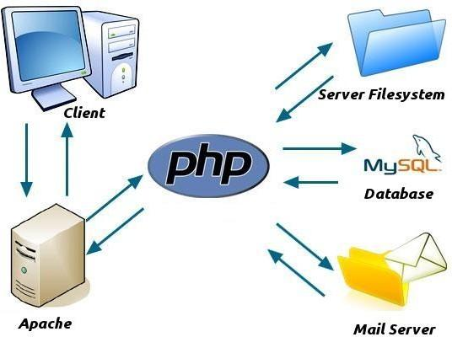

# JAVA SCRIPT

**JavaScript**, often abbreviated as "JS", is a [high-level](https://en.wikipedia.org/wiki/High-level_programming_language), [dynamic,](https://en.wikipedia.org/wiki/Dynamic_programming_language) [untyped](https://en.wikipedia.org/wiki/Untyped_language), and [interpreted](https://en.wikipedia.org/wiki/Interpreted_language) run-time [language](https://en.wikipedia.org/wiki/Programming_language). It has been standardized in the [ECMAScript](https://en.wikipedia.org/wiki/ECMAScript) language specification. Alongside [HTML](https://en.wikipedia.org/wiki/HTML) and [CSS,](https://en.wikipedia.org/wiki/CSS) JavaScript is one of the three core technologies of [World Wide Web](https://en.wikipedia.org/wiki/World_Wide_Web) [content production](https://en.wikipedia.org/wiki/Content_engineering); the majority of [websites](https://en.wikipedia.org/wiki/Website) employ it, and all modern [Web](https://en.wikipedia.org/wiki/Web_browser) [browsers](https://en.wikipedia.org/wiki/Web_browser) support it without the need for [plug-ins](https://en.wikipedia.org/wiki/Browser_extension). JavaScript is [prototype-based](https://en.wikipedia.org/wiki/Prototype-based_programming) with [first-class](https://en.wikipedia.org/wiki/First-class_function) [functions](https://en.wikipedia.org/wiki/First-class_function), making it a [multi-paradigm](https://en.wikipedia.org/wiki/Multi-paradigm) language, supporting [object-oriented](https://en.wikipedia.org/wiki/Object-oriented_programming), [imperative](https://en.wikipedia.org/wiki/Imperative_programming), and [functional](https://en.wikipedia.org/wiki/Functional_programming) [programming styles](https://en.wikipedia.org/wiki/Programming_paradigm). It has an [API](https://en.wikipedia.org/wiki/Application_programming_interface) for working with text, [arrays](https://en.wikipedia.org/wiki/Array_data_type), dates and [regular](https://en.wikipedia.org/wiki/Regular_expression) [expressions](https://en.wikipedia.org/wiki/Regular_expression), but does not include any [I/O](https://en.wikipedia.org/wiki/Input/output), such as networking, storage, or graphics facilities, relying for these upon the host environment in which it is embedded. Although there are strong outward similarities between JavaScript and Java, including language name, [syntax](https://en.wikipedia.org/wiki/Syntax_%28programming_languages%29), and respective [standard libraries](https://en.wikipedia.org/wiki/Standard_library), the two are distinct languages and differ greatly in their design. JavaScript was influenced by programming languages such as [self](https://en.wikipedia.org/wiki/Self_%28programming_language%29) and [Scheme.](https://en.wikipedia.org/wiki/Scheme_%28programming_language%29)

JavaScript is also used in environments that are not Web-based, such as [PDF](https://en.wikipedia.org/wiki/Portable_Document_Format) documents, [site-specific browsers](https://en.wikipedia.org/wiki/Site-specific_browser), and [desktop widgets](https://en.wikipedia.org/wiki/Desktop_widget). Newer and faster JavaScript [virtual](https://en.wikipedia.org/wiki/Virtual_machine) [machines](https://en.wikipedia.org/wiki/Virtual_machine) (VMs) and platforms built upon them have also increased the popularity of JavaScript for [server-side](https://en.wikipedia.org/wiki/Server-side) [Web applications](https://en.wikipedia.org/wiki/Web_application). On the [client side](https://en.wikipedia.org/wiki/Client_side), developers have traditionally implemented JavaScript as an [interpreted](https://en.wikipedia.org/wiki/Interpreter_%28computing%29) language, but more recent browsers perform [just-in-time](https://en.wikipedia.org/wiki/Just-in-time_compilation) [compilation](https://en.wikipedia.org/wiki/Just-in-time_compilation). Programmers also use JavaScript in [video-game development](https://en.wikipedia.org/wiki/Video_game_development), in crafting desktop and mobile applications, and in server-side [network programming](https://en.wikipedia.org/wiki/Computer_network_programming) with [run-time environments](https://en.wikipedia.org/wiki/Runtime_system) such as [Node.js](https://en.wikipedia.org/wiki/Node.js).

## JQUERY

**JQuery** is a [cross-platform](https://en.wikipedia.org/wiki/Cross-platform) [JavaScript library](https://en.wikipedia.org/wiki/JavaScript_library) designed to simplify the [client-side](https://en.wikipedia.org/wiki/Client-side_scripting) [scripting](https://en.wikipedia.org/wiki/Client-side_scripting) of [HTML.](https://en.wikipedia.org/wiki/HTML) It is [free, open-source software](https://en.wikipedia.org/wiki/Free_and_open_source_software) using the permissive [MIT license](https://en.wikipedia.org/wiki/MIT_license). [Web](https://en.wikipedia.org/wiki/World_Wide_Web) analysis indicates that it is the most widely deployed JavaScript library by a large margin.

jQuery's syntax is designed to make it easier to navigate a document, select [DOM](https://en.wikipedia.org/wiki/Document_Object_Model) elements, create [animations](https://en.wikipedia.org/wiki/Animation), handle [events](https://en.wikipedia.org/wiki/Event_%28computing%29), and develop [Ajax](https://en.wikipedia.org/wiki/Ajax_%28programming%29) applications. jQuery also provides capabilities for developers to create [plug-ins](https://en.wikipedia.org/wiki/Plug-in_%28computing%29) on top of the JavaScript library. This enables developers to create [abstractions](https://en.wikipedia.org/wiki/Abstraction_%28computer_science%29) for low-level interaction and animation, advanced effects and high-level, themeable widgets. The modular approach to the jQuery library allows the creation of powerful [dynamic web pages](https://en.wikipedia.org/wiki/Dynamic_web_page) and Web applications.

The set of [jQuery core features](https://en.wikipedia.org/wiki/JQuery#Features)—DOM element selections, traversal and manipulation—enabled by its selector engine (named "Sizzle" from v1.3), created a new "programming style", fusing algorithms and DOM data structures. This style influenced the architecture of other [JavaScript frameworks](https://en.wikipedia.org/wiki/Comparison_of_JavaScript_frameworks) like [YUI v3](https://en.wikipedia.org/wiki/YUI_Library) and [Dojo](https://en.wikipedia.org/wiki/Dojo_Toolkit), later stimulating the creation of the standard Selectors API.

[Microsoft](https://en.wikipedia.org/wiki/Microsoft) and [Nokia](https://en.wikipedia.org/wiki/Nokia) bundle jQuery on their platforms. Microsoft includes it with [Visual Studio](https://en.wikipedia.org/wiki/Microsoft_Visual_Studio) for use within Microsoft's [ASP.NET AJAX](https://en.wikipedia.org/wiki/ASP.NET_AJAX) and [ASP.NET MVC](https://en.wikipedia.org/wiki/ASP.NET_MVC) frameworks while Nokia has integrated it into the Web Run-Time widget development platform.



**Xampp** is a [free and open source](https://en.wikipedia.org/wiki/Free_software) [cross platform](https://en.wikipedia.org/wiki/Cross-platform) [web server](https://en.wikipedia.org/wiki/Web_server) [solution stack](https://en.wikipedia.org/wiki/Solution_stack) package developed by Apache Friends, consisting mainly of the [Apache HTTP Server](https://en.wikipedia.org/wiki/Apache_HTTP_Server), [MariaDB](https://en.wikipedia.org/wiki/MariaDB) [database](https://en.wikipedia.org/wiki/Database), and [interpreters](https://en.wikipedia.org/wiki/Interpreter_%28computing%29) for scripts written in the [PHP](https://en.wikipedia.org/wiki/PHP) and [Perl](https://en.wikipedia.org/wiki/Perl) [programming languages](https://en.wikipedia.org/wiki/Programming_language).XAMPP stands for Cross-Platform (X), Apache (A), MariaDB (M), PHP (P) and Perl (P). It is

simple, lightweight Apache distribution that makes it extremely easy for developers to create a local web server for testing and deployment purposes. Everything needed to set up a web server – server application (Apache), database (MariaDB), and scripting language (PHP) – is included in an extractable file. XAMPP is also cross-platform, which means it works equally well on Linux, Mac and Windows. Since most actual web server deployments use the same components as XAMPP, it makes transitioning from a local test server to a live server extremely easy as well.

## FEATURES

XAMPP is regularly updated to the latest releases of [Apache](https://en.wikipedia.org/wiki/Apache_HTTP_Server), [MariaDB](https://en.wikipedia.org/wiki/MariaDB), [PHP](https://en.wikipedia.org/wiki/PHP) and [Perl](https://en.wikipedia.org/wiki/Perl). It also comes with a number of other modules including [OpenSSL](https://en.wikipedia.org/wiki/OpenSSL), [phpMyAdmin](https://en.wikipedia.org/wiki/PhpMyAdmin), [MediaWiki](https://en.wikipedia.org/wiki/MediaWiki), [Joomla](https://en.wikipedia.org/wiki/Joomla), [WordPress](https://en.wikipedia.org/wiki/WordPress) and more. Self-contained, multiple instances of XAMPP can exist on a single computer, and any given instance can be copied from one computer to another. XAMPP is offered in both a full and a standard version (Smaller version).

## USAGE

Officially, XAMPP's designers intended it for use only as a development tool, to allow website designers and programmers to test their work on their own computers without any access to the Internet. To make this as easy as possible, many important security features are disabled by default. XAMPP has the ability to serve web pages on the [World Wide Web.](https://en.wikipedia.org/wiki/World_Wide_Web) A special tool is provided to [password-protect](https://en.wikipedia.org/wiki/Password) the most important parts of the package.

XAMPP also provides support for creating and manipulating databases in [MariaDB](https://en.wikipedia.org/wiki/MariaDB) and [SQLite](https://en.wikipedia.org/wiki/SQLite) among others. Once XAMPP is installed, it is possible to treat a [localhost](https://en.wikipedia.org/wiki/Localhost) like a remote host by connecting using an [FTP](https://en.wikipedia.org/wiki/File_Transfer_Protocol) client. Using a program like [FileZilla](https://en.wikipedia.org/wiki/FileZilla) has many advantages when installing a [content management system](https://en.wikipedia.org/wiki/Content_management_system) (CMS) like [Joomla](https://en.wikipedia.org/wiki/Joomla) or [WordPress](https://en.wikipedia.org/wiki/WordPress). It is also possible to connect to localhost via FTP with an [HTML editor](https://en.wikipedia.org/wiki/HTML_editor).

TECHNICAL DETAILS:

* + - Front end is designed using HTML, CSS and Bootstrap. JavaScript used to perform client side scripting
    - Backend is based on PHP + MySql based RDB(Relational Data Base) model.
    - The SQL queries are run using the CI SQL library functions
    - Backend online host includes a centralized database resident on the server, the script which is built in PHP used to SQL query the database on user’s request for transaction of data
    - The forms are made using the HTML, Bootstrap for designing and Php, sql for back-end
    - JavaScript, and JQuery used for client side scripting and PHP for the server side development

METHODOLOGY

# USE CASE DIAGRAM

A [UML](https://en.wikipedia.org/wiki/Unified_Modeling_Language) use case diagram is the primary form of system/software requirements for a new software program underdeveloped. Use cases specify the expected behavior (what), and not the exact method of making it happen (how). Use cases once specified can be denoted both textual and visual representation (i.e. use case diagram). A key concept of use case modeling is that it helps us design a system from the end user's perspective. It is an effective technique for communicating system behavior in the user's terms by specifying all externally visible system behavior.

A use case diagram is usually simple. It does not show the detail of the use cases:

* It only summarizes **some of the relationships** between use cases, actors, and systems.
* It does **not show the order** in which steps are performed to achieve the goals of each use case.

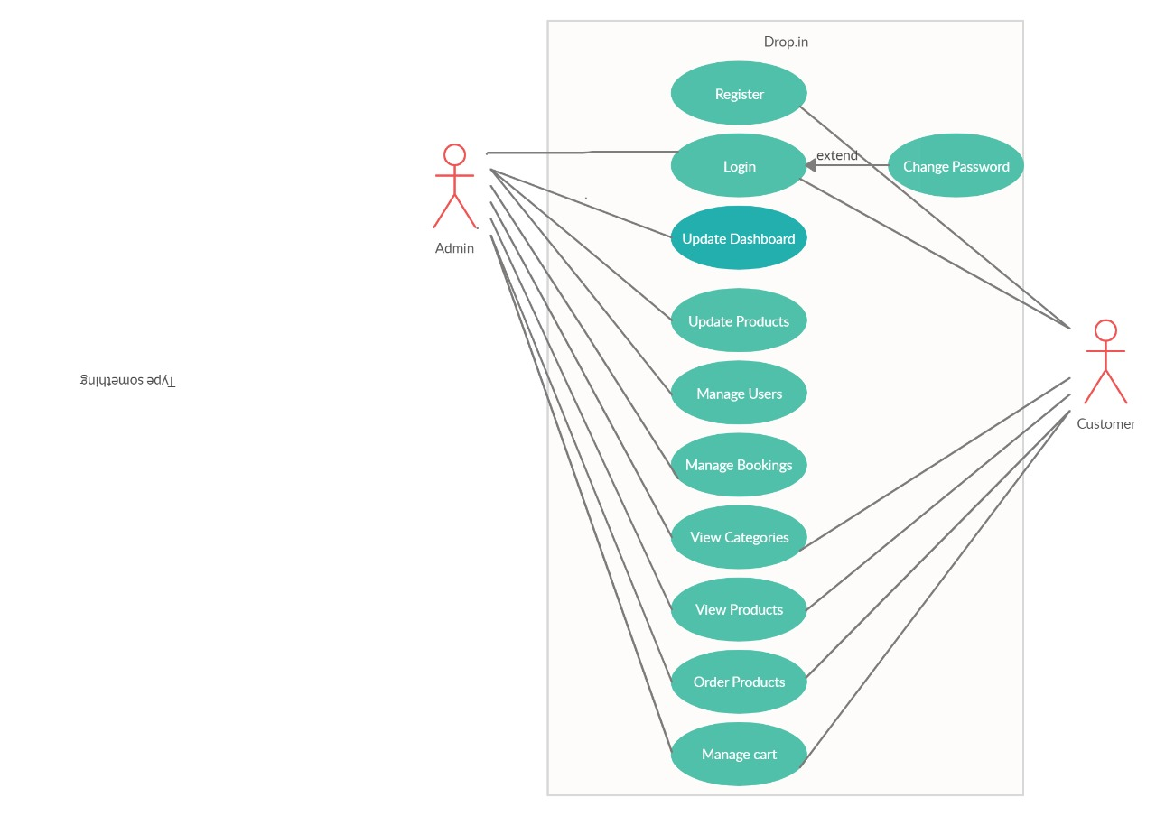

# 

# 

# DATA FLOW DIAGRAM

Also known as DFD, Data flow diagrams are used to graphically represent the flow of data in a business information system. DFD describes the processes that are involved in a system to transfer data from the input to the file storage and reports generation.

Data flow diagrams can be divided into logical and physical. The logical data flow diagram describes flow of data through a system to perform certain functionality of a business. The physical data flow diagram describes the implementation of the logical data flow.

DFD graphically representing the functions, or processes, which capture, manipulate, store, and distribute data between a system and its environment and between components of a system. The visual representation makes it a good communication tool between User and System designer. Structure of DFD allows starting from a broad overview and expand it to a hierarchy of detailed diagrams. DFD has often been used due to the following reasons:

* Logical information flow of the system
* Determination of physical system construction requirements
* Simplicity of notation
* Establishment of manual and automated systems requirements

LEVEL 0

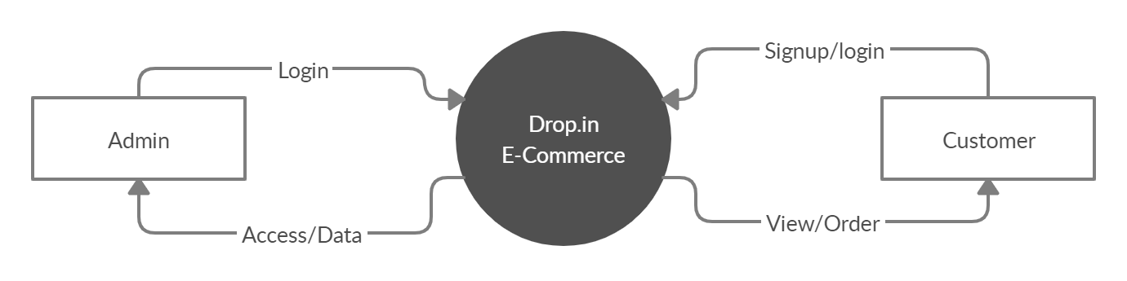

LEVEL 1

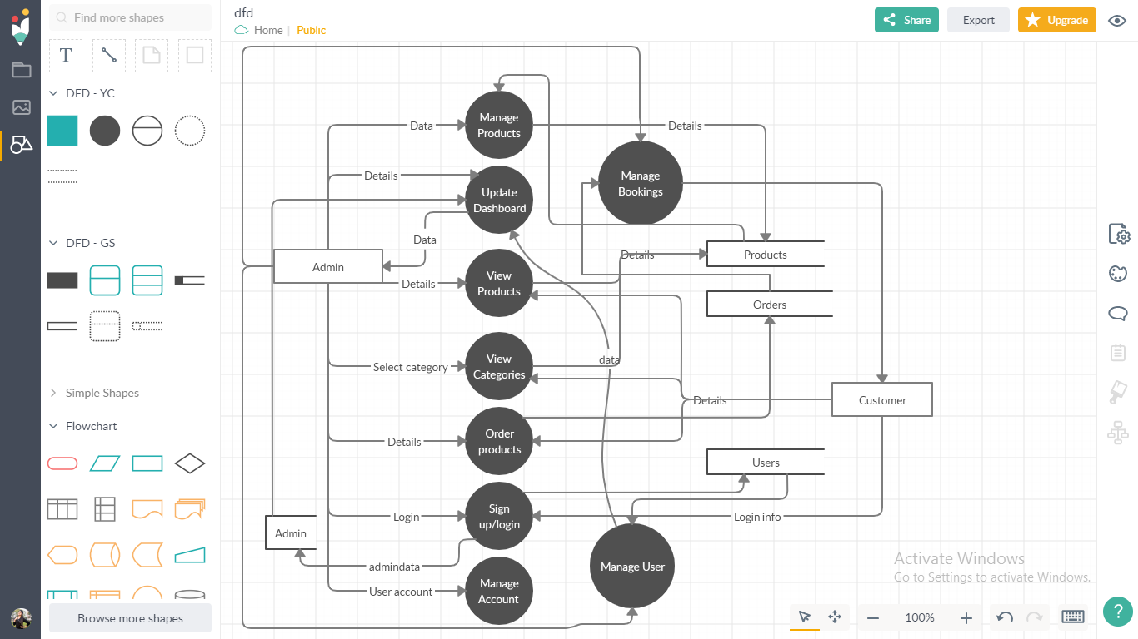

# Implementation Details

Front end of the project has been designed to some extent. We will keep on modifying these parts as we simultaneously work on the back-end of the product.

Screenshots:

# User portal

The index page is usually the first page that a user sees when he/she visits a

website. This is how our index page should look like:

This is a web page contains three sections:

1. Header

2. Content

3. Footer

Header: This is the first section of the webpage and it contains the “The Lifestyle Store” as a

website name and navigation links to login and signup page.

Content: This section has two parts banner image with a Shop Now button over it and item category

Footer: The footer contains text “Copyright @ Drop.in All Rights Reserved

| Contact Us: +91 90000 00000 ”.

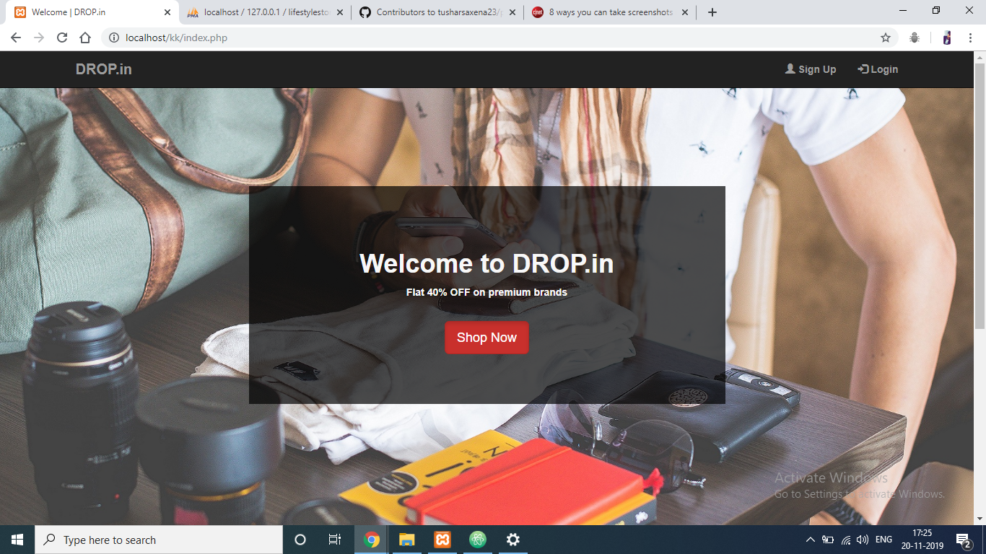

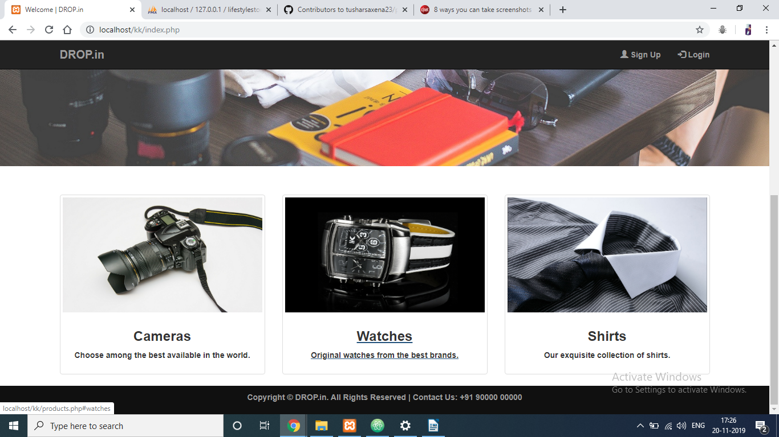

We’ve added the sign up page for the new users coming to the websites. The users can view products and page without logging in, but to order products, the user will have to register.

After registering the user is exposed to better functionalities as they try to explore more out of the website

The user can now add products to the cart and make an order. Also user can log out and surf without logging in.

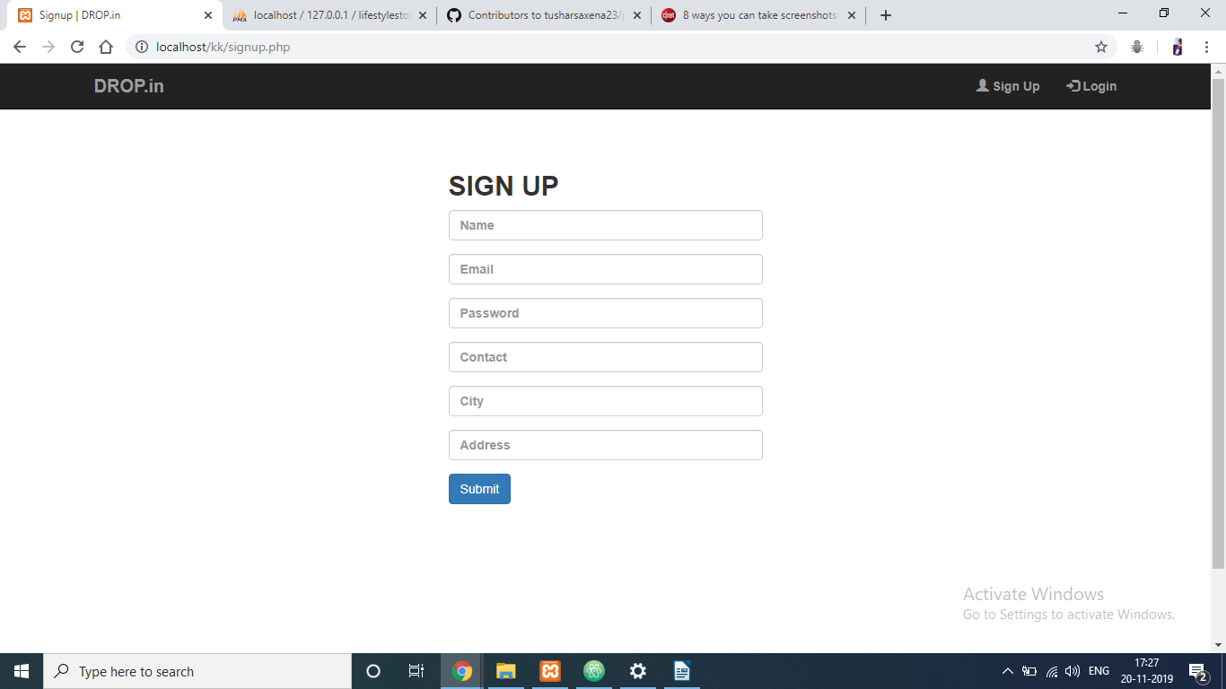

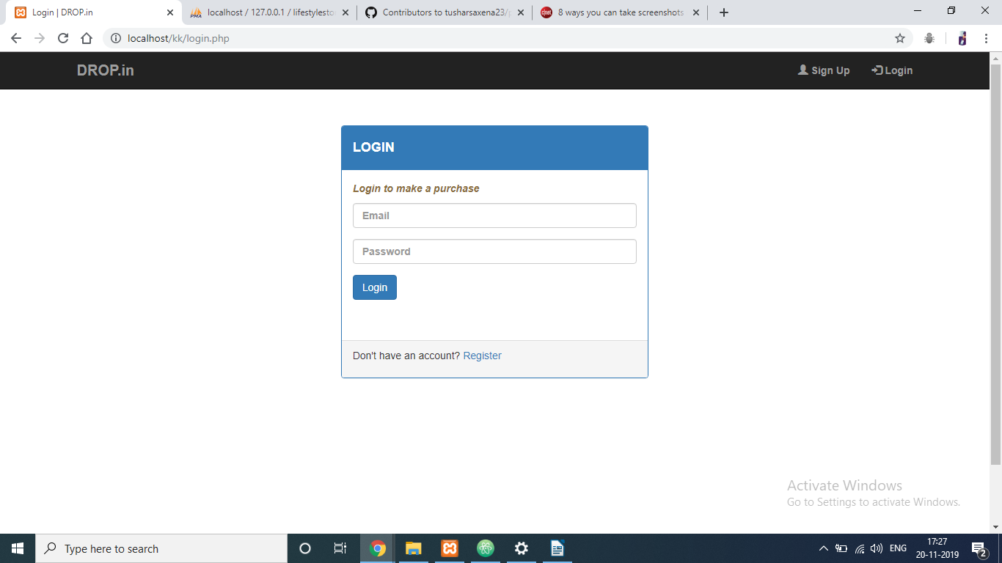

As soon as the user logs into the website, the website layout changes.

The user can now see:

* Cart- Can be used to add items to the cart for ordering or save for ordering it later sometime.
* Settings- Settings can be used to change the password in case the user forgets the passwors after logging in or just wants to change it.
* Logout- The user has the option to log out of the website anytime that it wants and can continue surfing the products

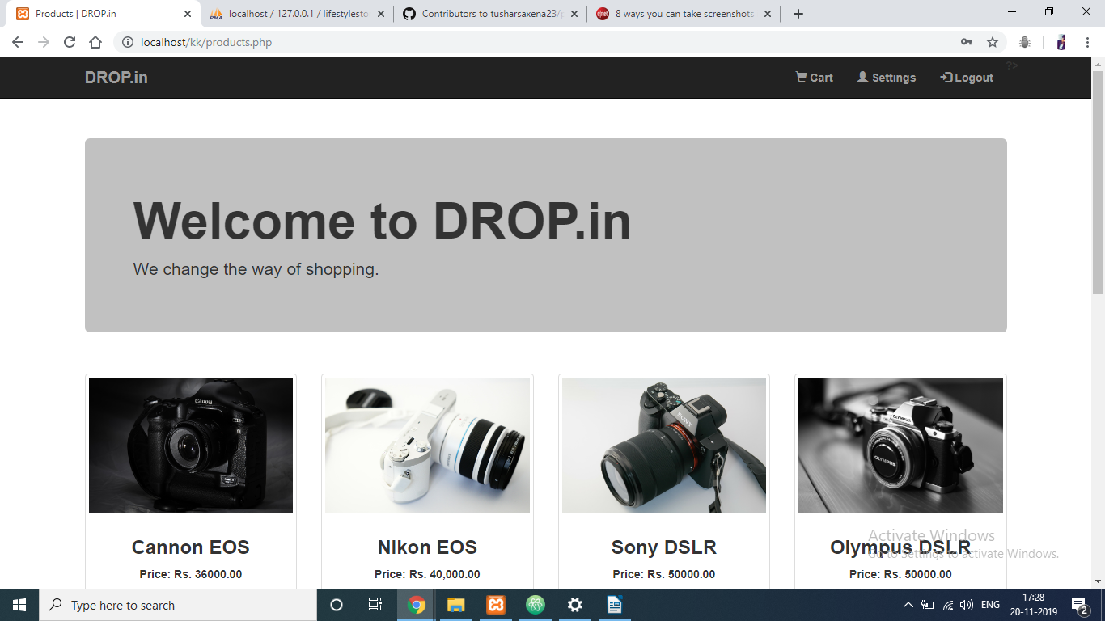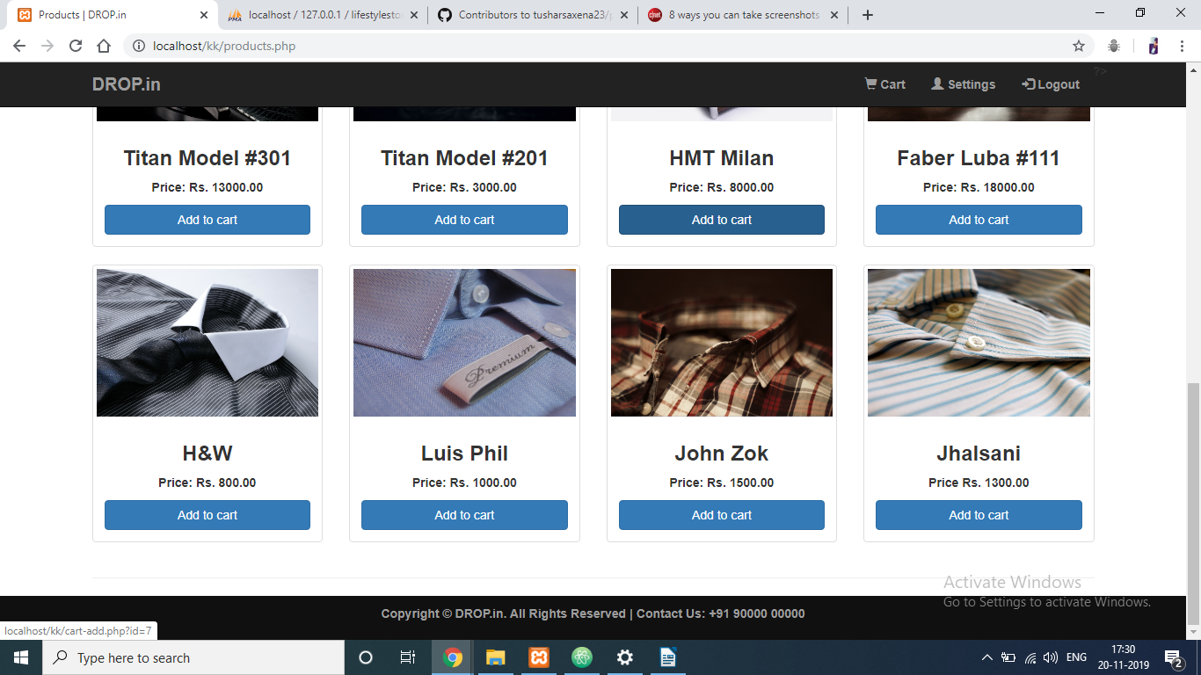

Admin Portal

The admin portal lets the admin check and manage the entire website.

The admin has the facility to:

1.Update Dashboards- The admin can add the important parts of it’s analysis from the website and the content to a single page.

2.Add new item- New items/products can be added by the admin. Products can be introduced to the website using this.

3.Delete item- For an item that is no longer in stocks or if the admin just wants to delete, it can be done easily

4.See item list- Items list can be seen with the help of this functionality. The admin can check details about the items

5.Manage bookings- The admin can manage the orders that have been made by the customers and hence manage all the bookings

6.Manage users- The admin can manage the users that have logged in and are checking into the website.

# Admin portal:

# 

# 

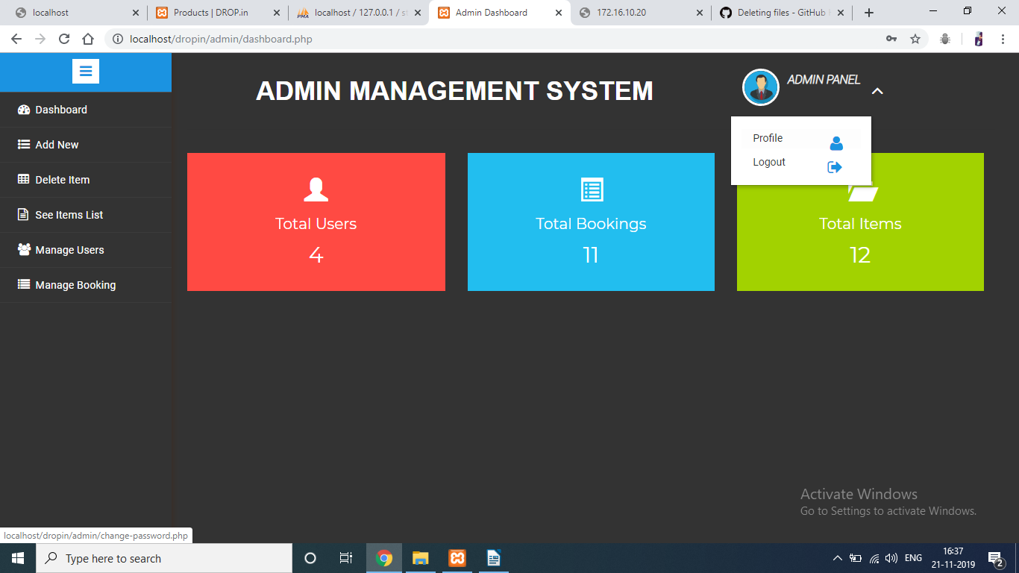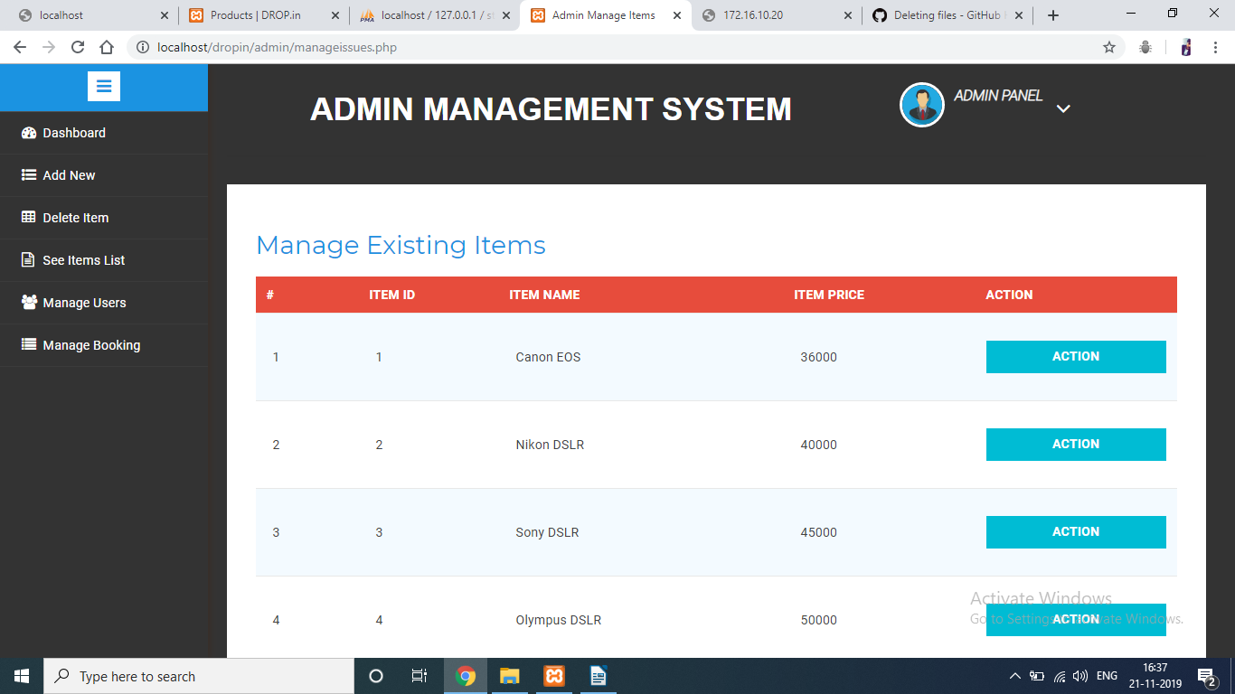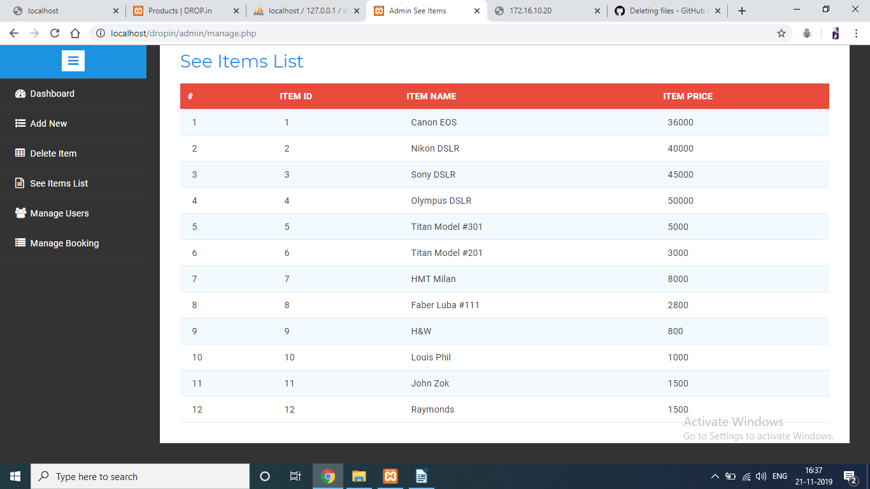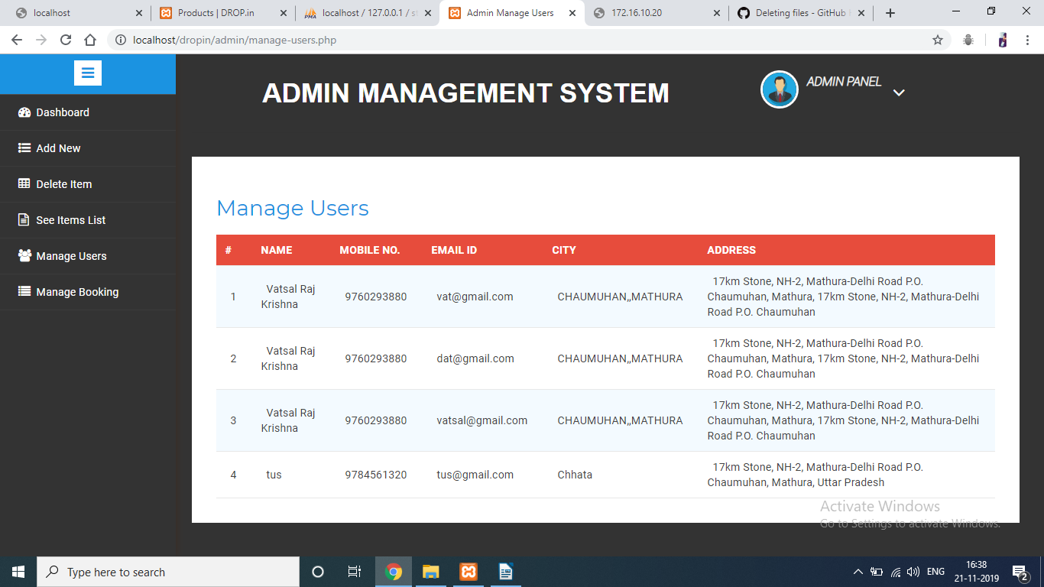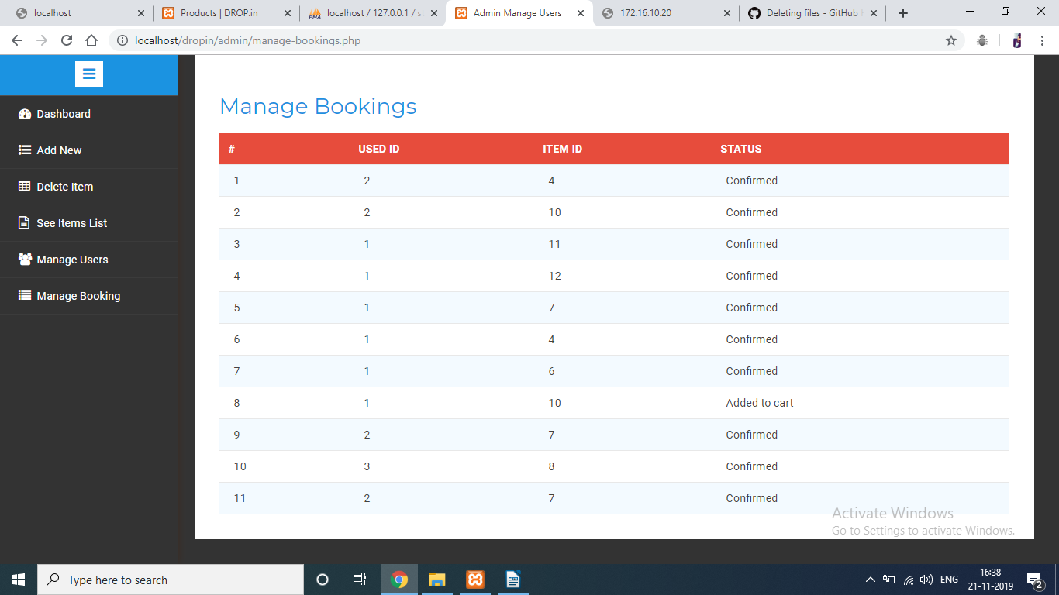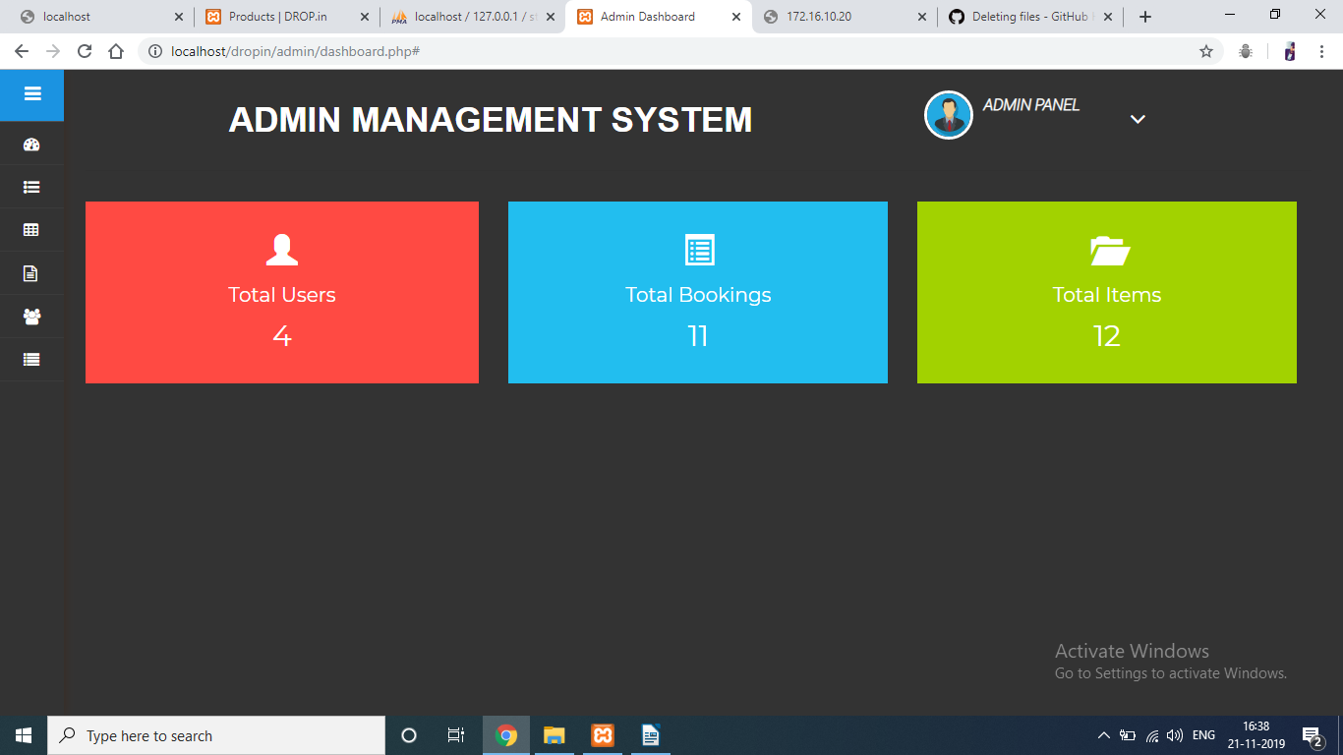

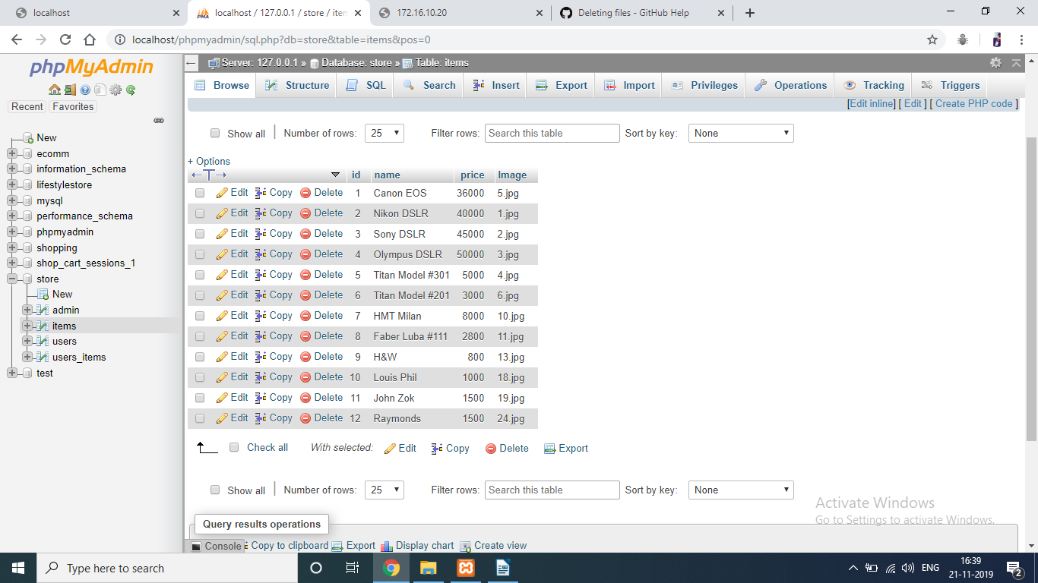

The database created has provided us the facility to view all the datastores and even modify them. The databases are:

Admin: Contains data about the admin

Items: Contains data about all the [products on the page

Users: Contains data about the users

User Items: Contains data about the orders

Contribution Summary

Riya Narain: Front End, Methodology designing, Report, Target audience based interface

Tushar Saxena: Front End, Components, hardware/software based improvisations, backend report.

Progress Till Date

Whole project developed. Please refer to the ScreenShots

References

<https://www.udemy.com/course/the-complete-web-development-bootcamp/learn/lecture/12371312?start=255>